Single Sign-On your asp.net web app

1. Add user to the Active Directory

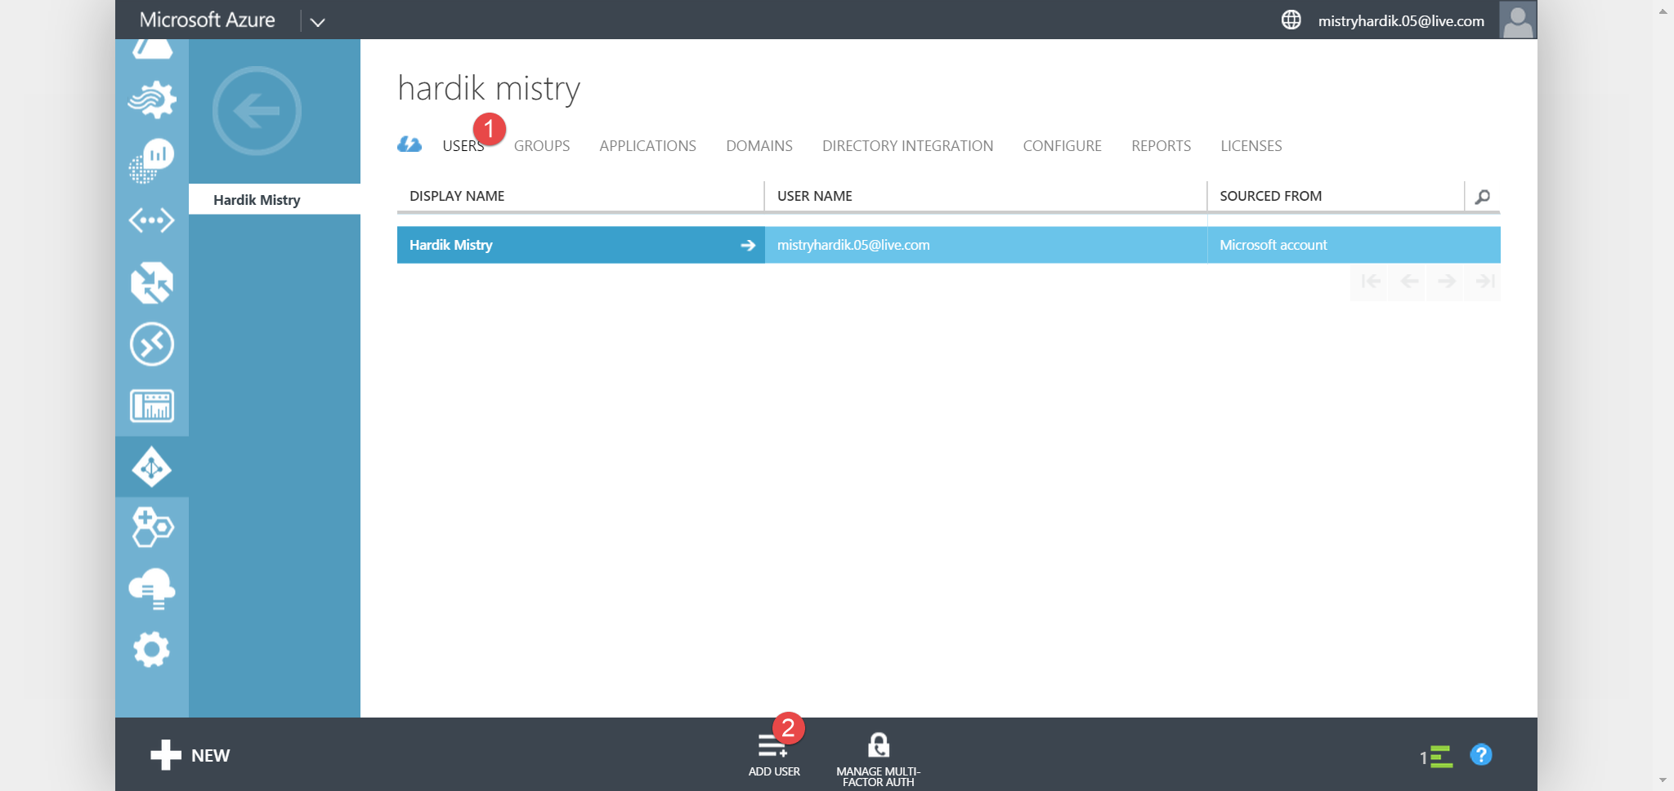

Give a username

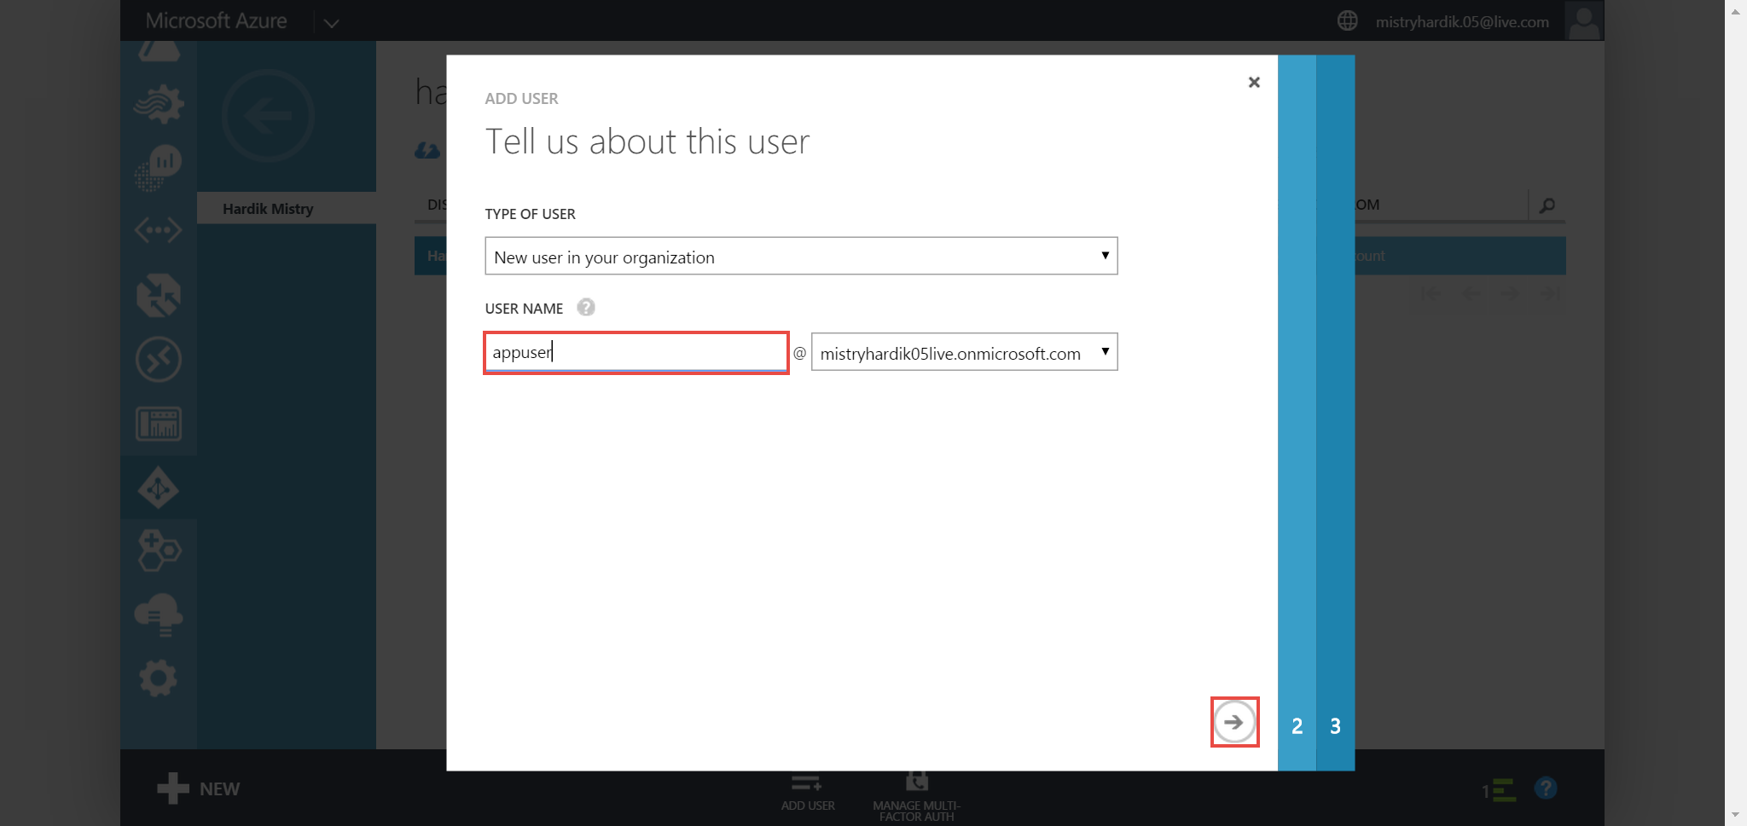

Fill in other details of the user you are adding, currently we are adding a user with User Role

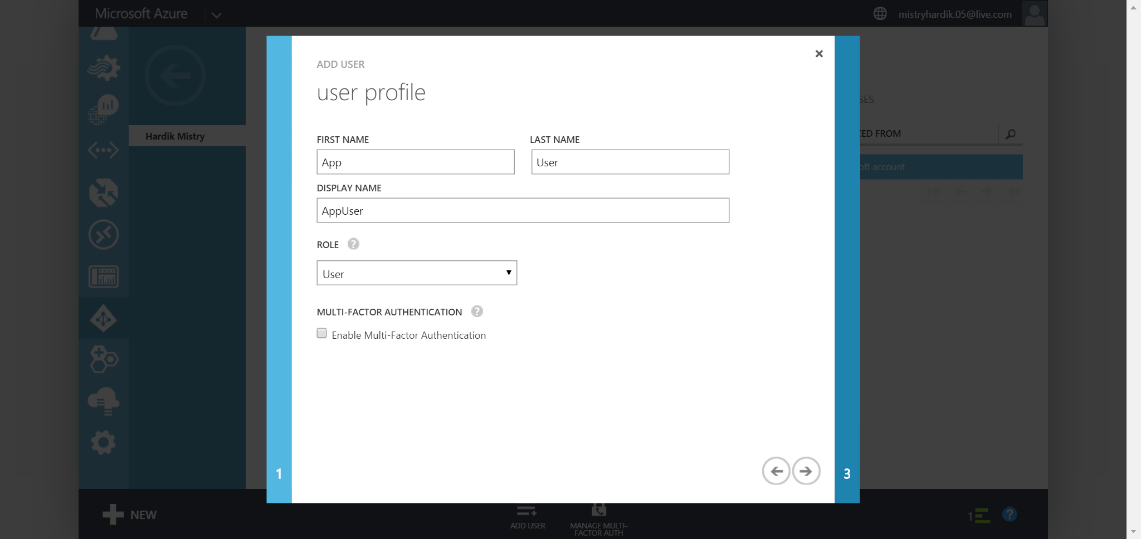

Copy and save the temporary password

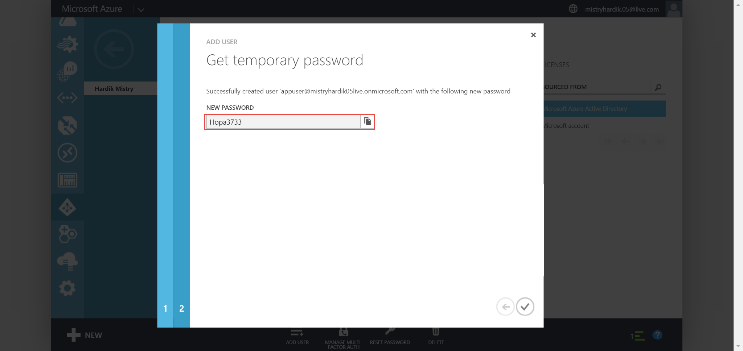

Create a new ASP.NET MVC Web Application



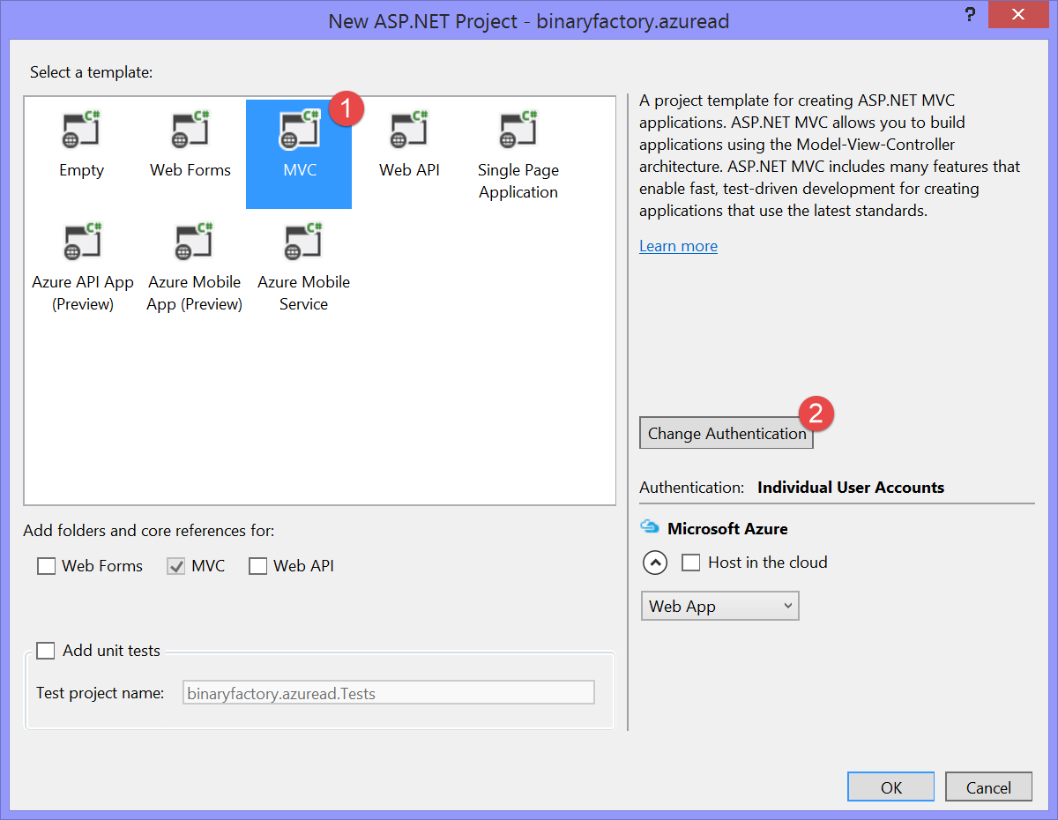

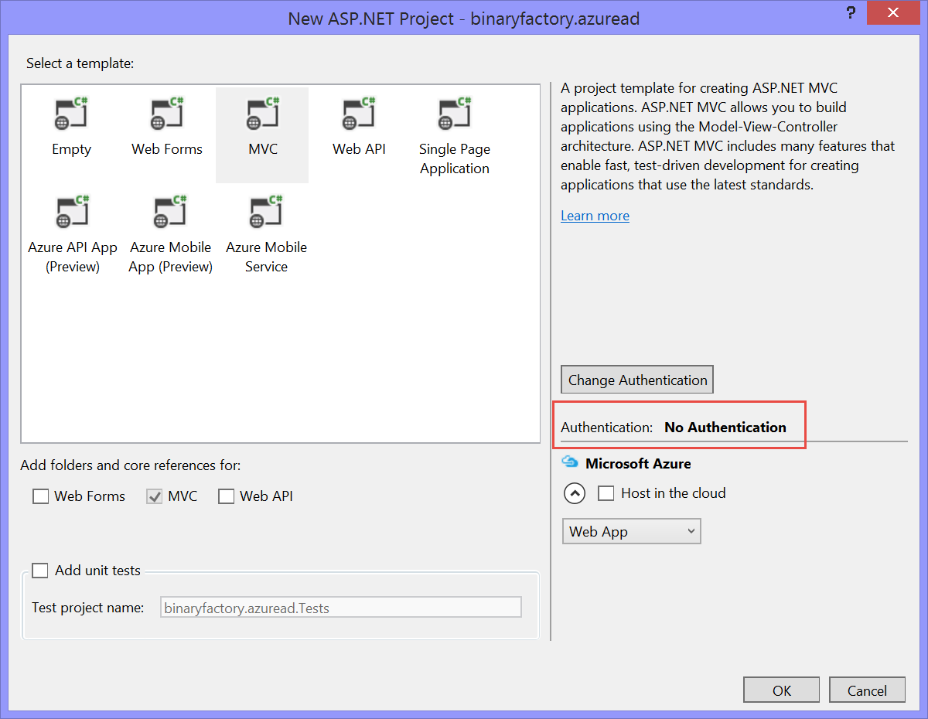

Add the following packages using the Nuget Package Manager

* Microsoft.Owin.IdentityModels.Protocol.Extensions (Tools – > Package Manager Console)

Install-Package Microsoft.IdentityModel.Protocol.Extensions -Version 1.0.3.308261200

* System.IdentityModel.Tokens.Jwt
* Microsoft.Owin.Security.OpenIdConnect
* Microsoft.Owin.Security.Cookies
* Microsoft.Owin.Host.SystemWeb

Right click App_Start folder and Add a class, name it Startup.Auth.cs

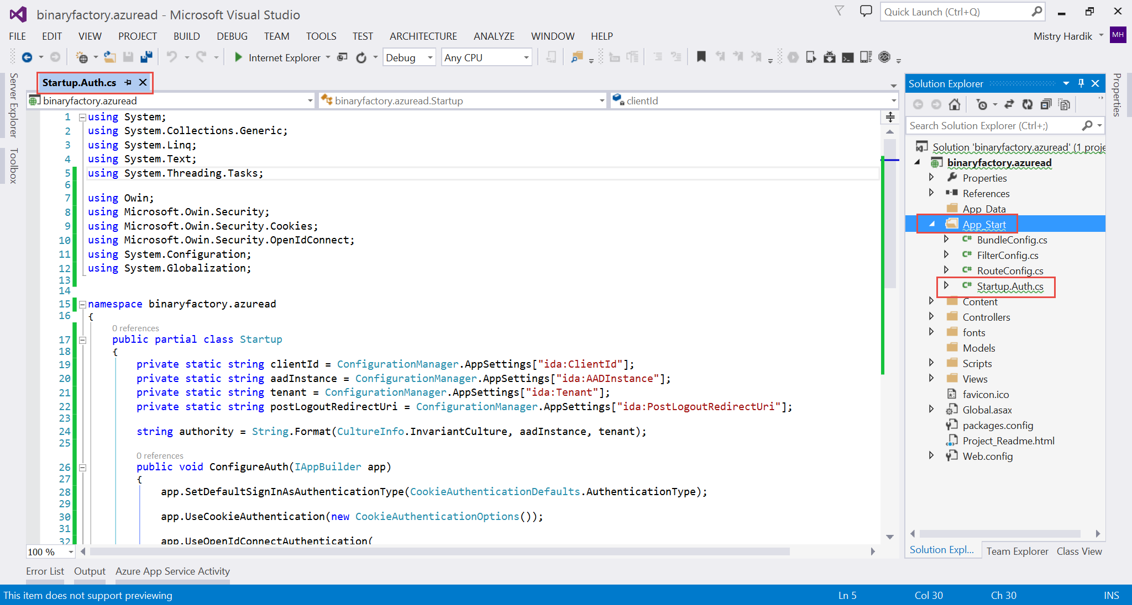

**Code:**

using System;

using System.Collections.Generic;

using System.Linq;

using System.Text;

using System.Threading.Tasks;

using Owin;

using Microsoft.Owin.Security;

using Microsoft.Owin.Security.Cookies;

using Microsoft.Owin.Security.OpenIdConnect;

using System.Configuration;

using System.Globalization;

namespace binaryfactory.azuread //replace this namespace with your project name

{

    public partial class Startup

    {

        private static string clientId = ConfigurationManager.AppSettings["ida:ClientId"];

        private static string aadInstance = ConfigurationManager.AppSettings["ida:AADInstance"];

        private static string tenant = ConfigurationManager.AppSettings["ida:Tenant"];

        private static string postLogoutRedirectUri = ConfigurationManager.AppSettings["ida:PostLoginRedirectUri"];

        string authority = String.Format(CultureInfo.InvariantCulture, aadInstance, tenant);

        public void ConfigureAuth(IAppBuilder app)

        {

            app.SetDefaultSignInAsAuthenticationType(CookieAuthenticationDefaults.AuthenticationType);

            app.UseCookieAuthentication(new CookieAuthenticationOptions());

            app.UseOpenIdConnectAuthentication(

                new OpenIdConnectAuthenticationOptions

                {

                    ClientId = clientId,

                    Authority = authority,

                    PostLogoutRedirectUri = postLogoutRedirectUri,

                    Notifications = new OpenIdConnectAuthenticationNotifications

                    {

                        AuthenticationFailed = context =>

                        {

                            context.HandleResponse();

                            context.Response.Redirect("/Error?message=" + context.Exception.Message);

                            return Task.FromResult(0);

                        }

                    }

                });

        }

    }

}

Right click the project and add a OWIN Startup Class and name is Startup.cs and add invoke ConfigureAuth(app) as shown

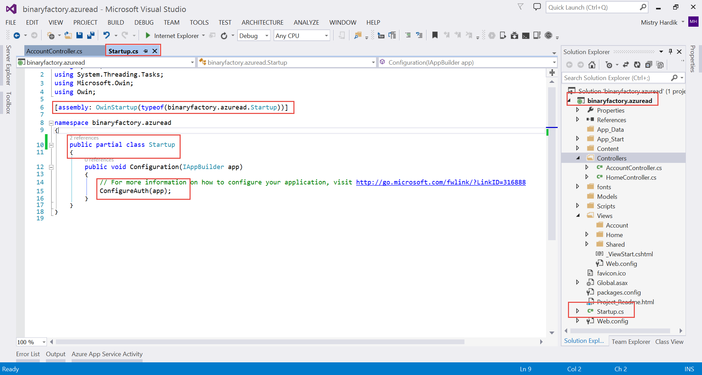

Right click the controllers folder and name it AccountController as shown

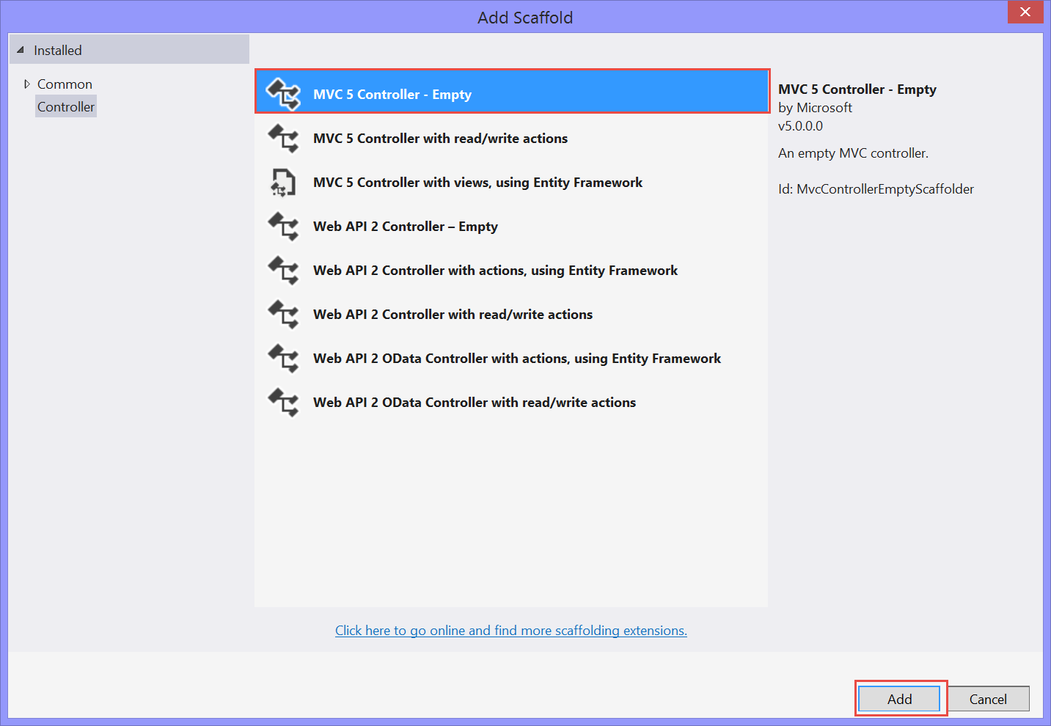

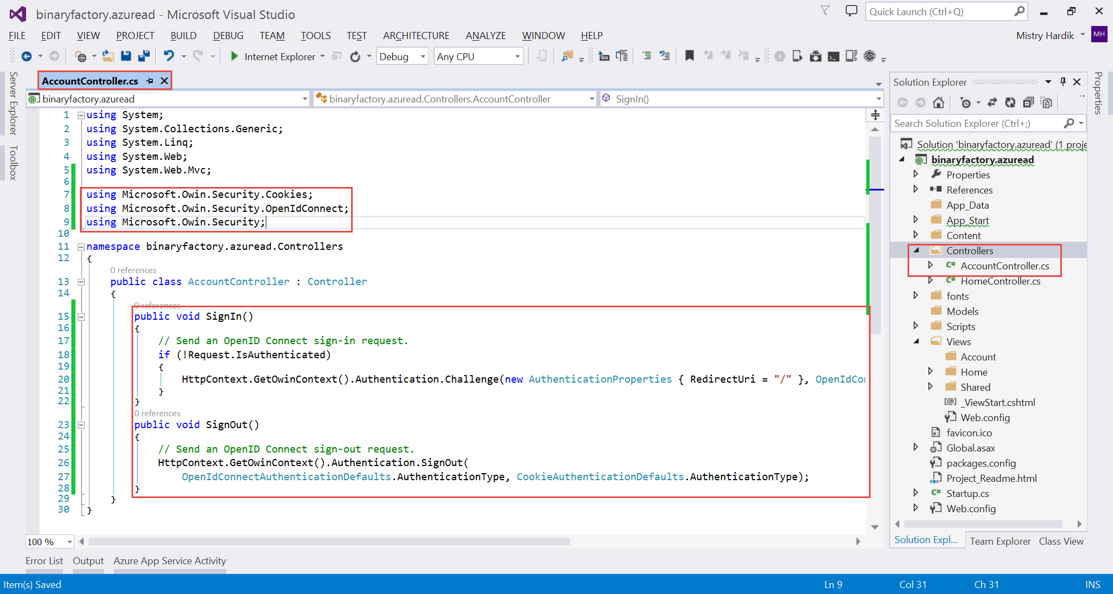

**Code: // copy paste the following as illustrated above**

using Microsoft.Owin.Security.Cookies;

using Microsoft.Owin.Security.OpenIdConnect;

using Microsoft.Owin.Security;

public void SignIn()

        {

            // Send an OpenID Connect sign-in request.

            if (!Request.IsAuthenticated)

            {

                HttpContext.GetOwinContext().Authentication.Challenge(new AuthenticationProperties { RedirectUri = "/" }, OpenIdConnectAuthenticationDefaults.AuthenticationType);

            }

        }

        public void SignOut()

        {

            // Send an OpenID Connect sign-out request.

            HttpContext.GetOwinContext().Authentication.SignOut(

                OpenIdConnectAuthenticationDefaults.AuthenticationType, CookieAuthenticationDefaults.AuthenticationType);

        }

Right click the View/Shared folder and add a MVC Partial page and name it _LoginPartial.cshtml as shown and copy the following code

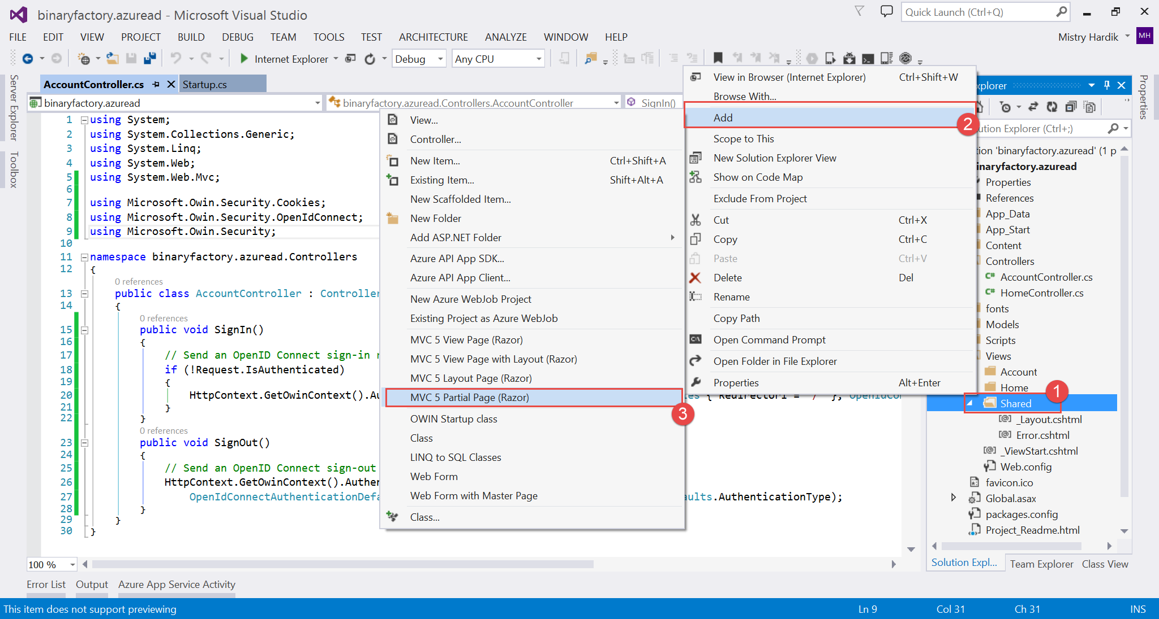

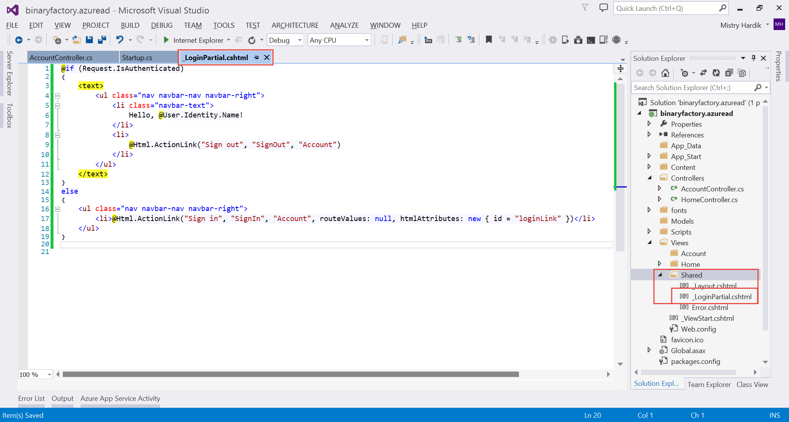

**Code:**

@if (Request.IsAuthenticated)

{

    <text>

        <ul class="nav navbar-nav navbar-right">

            <li class="navbar-text">

                Hello, @User.Identity.Name!

            </li>

            <li>

                @Html.ActionLink("Sign out", "SignOut", "Account")

            </li>

        </ul>

    </text>

}

else

{

    <ul class="nav navbar-nav navbar-right">

        <li>@Html.ActionLink("Sign in", "SignIn", "Account", routeValues: null, htmlAttributes: new { id = "loginLink" })</li>

    </ul>

}

Open the _Layout.cshtml and modified as shown below

@Html.Partial("_LoginPartial.cshtml")

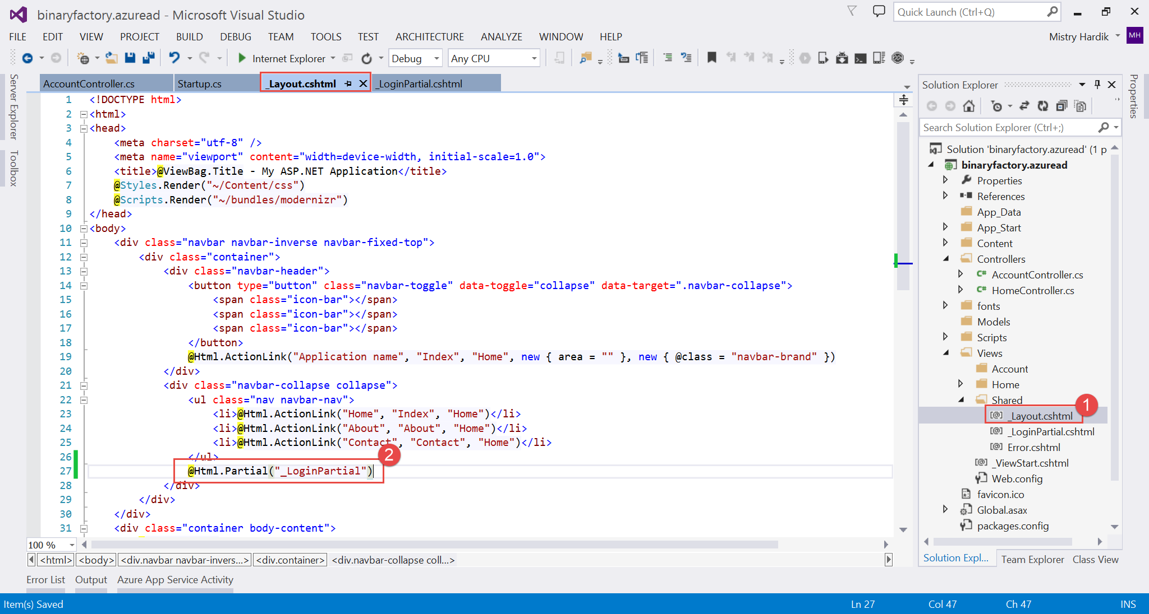

Enable SSL to the project, to do so, left click the project and press F4 on the keyboard and enable SSL and copy paste the url

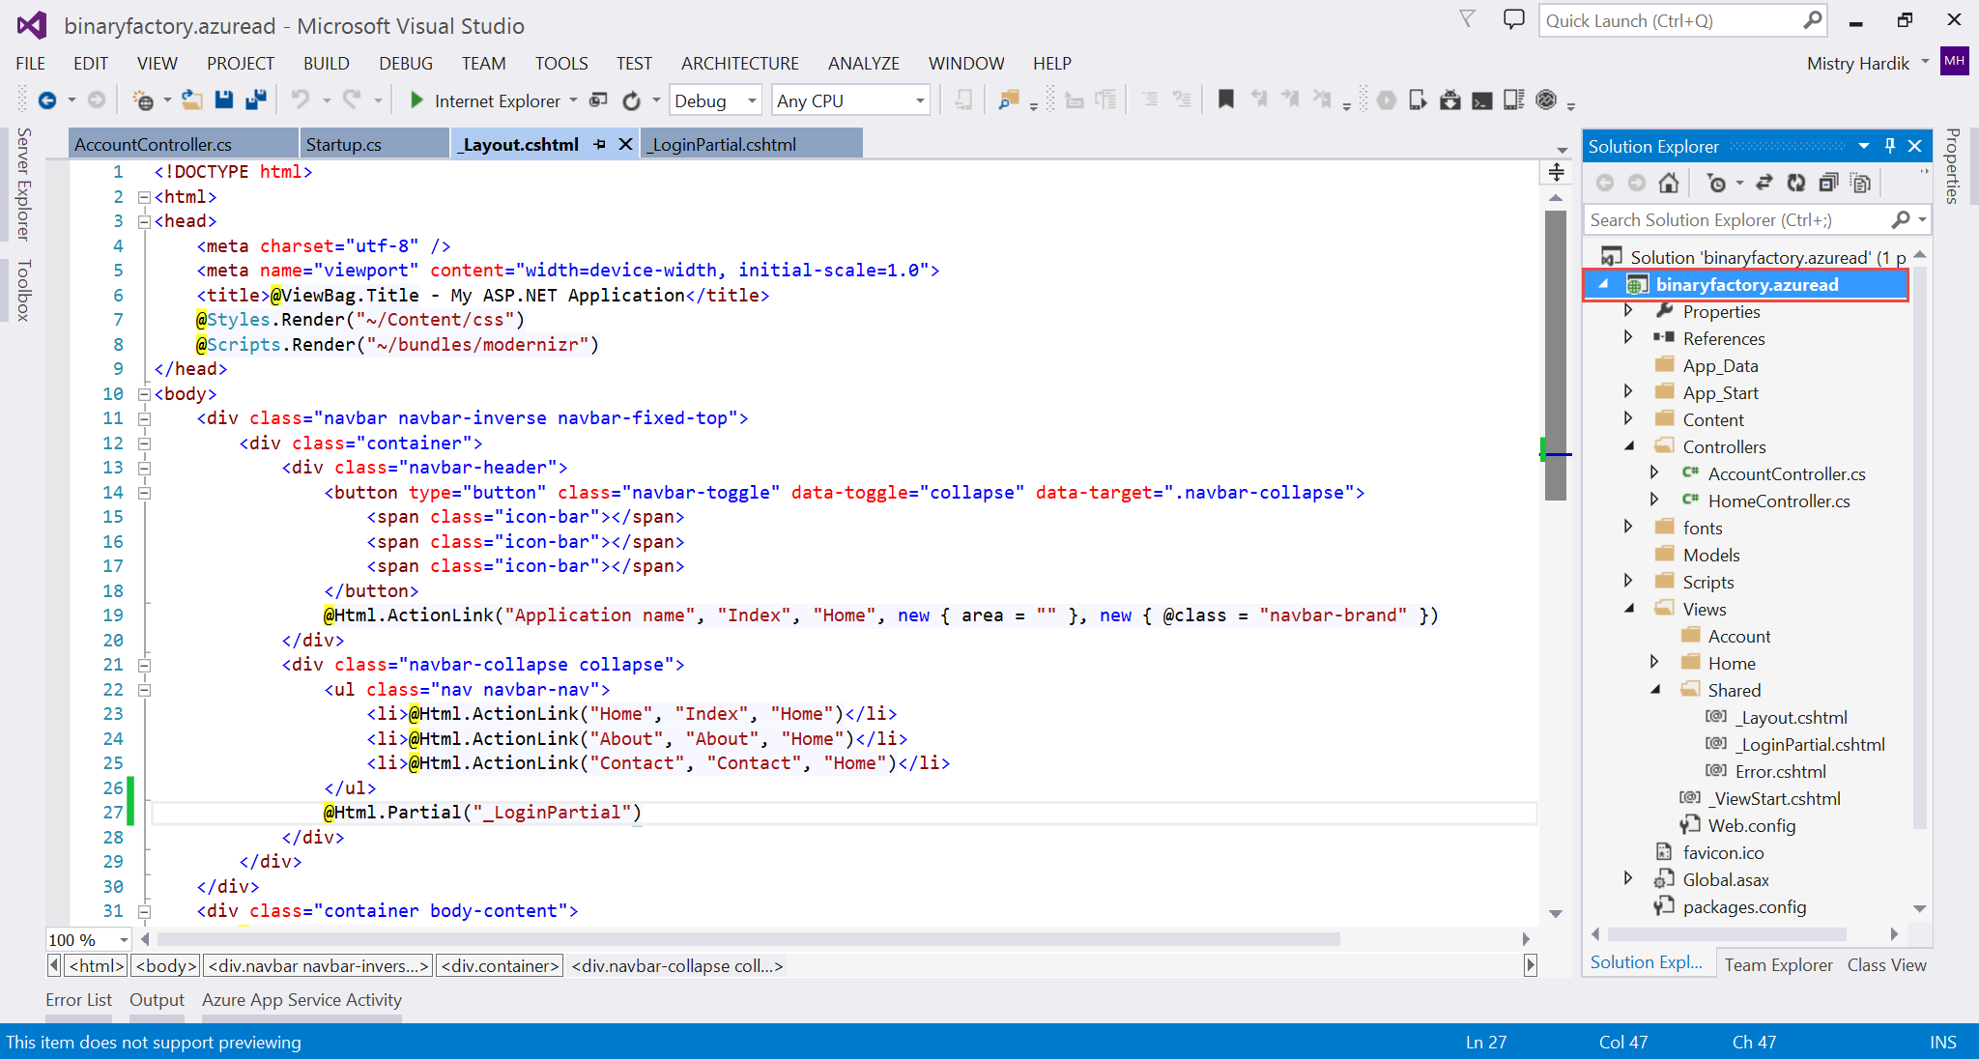

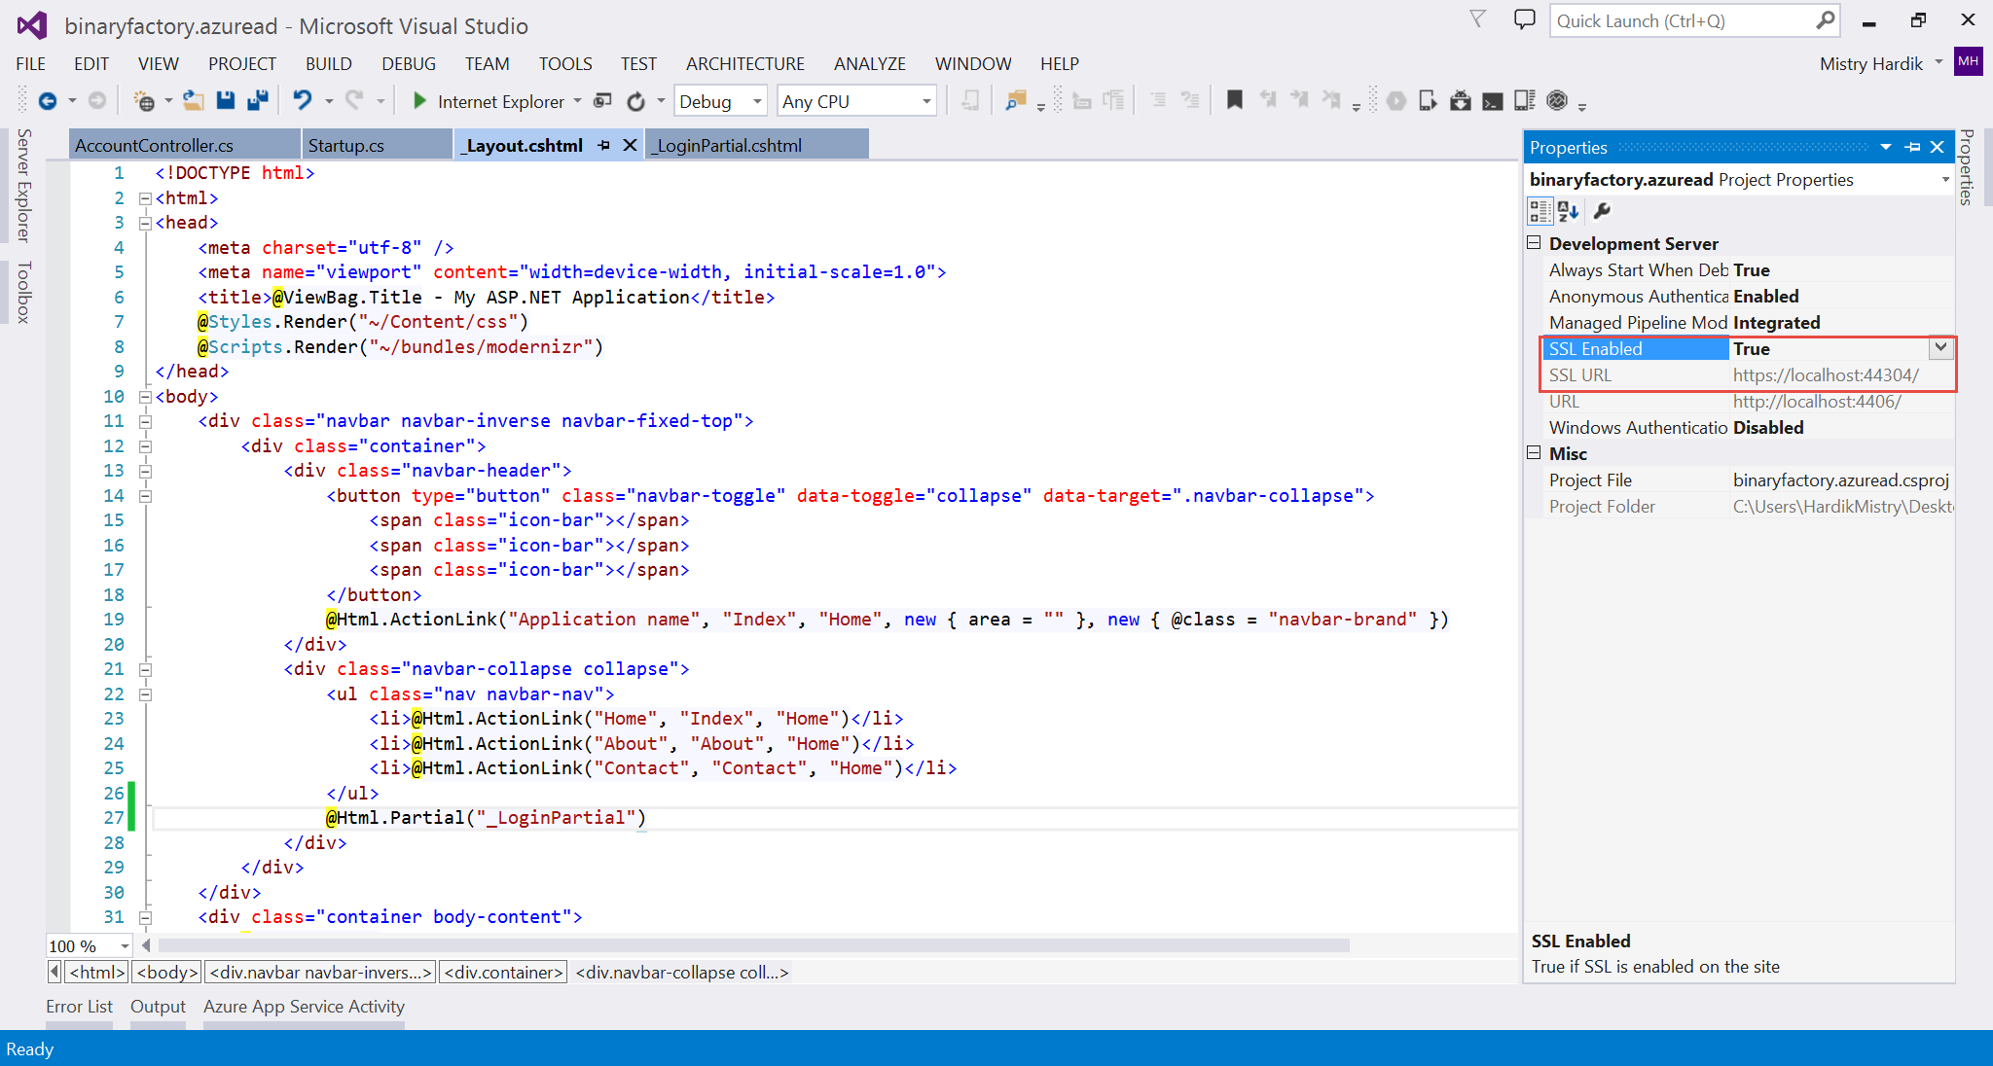

Copy the url and replace the url from web iis express runtime

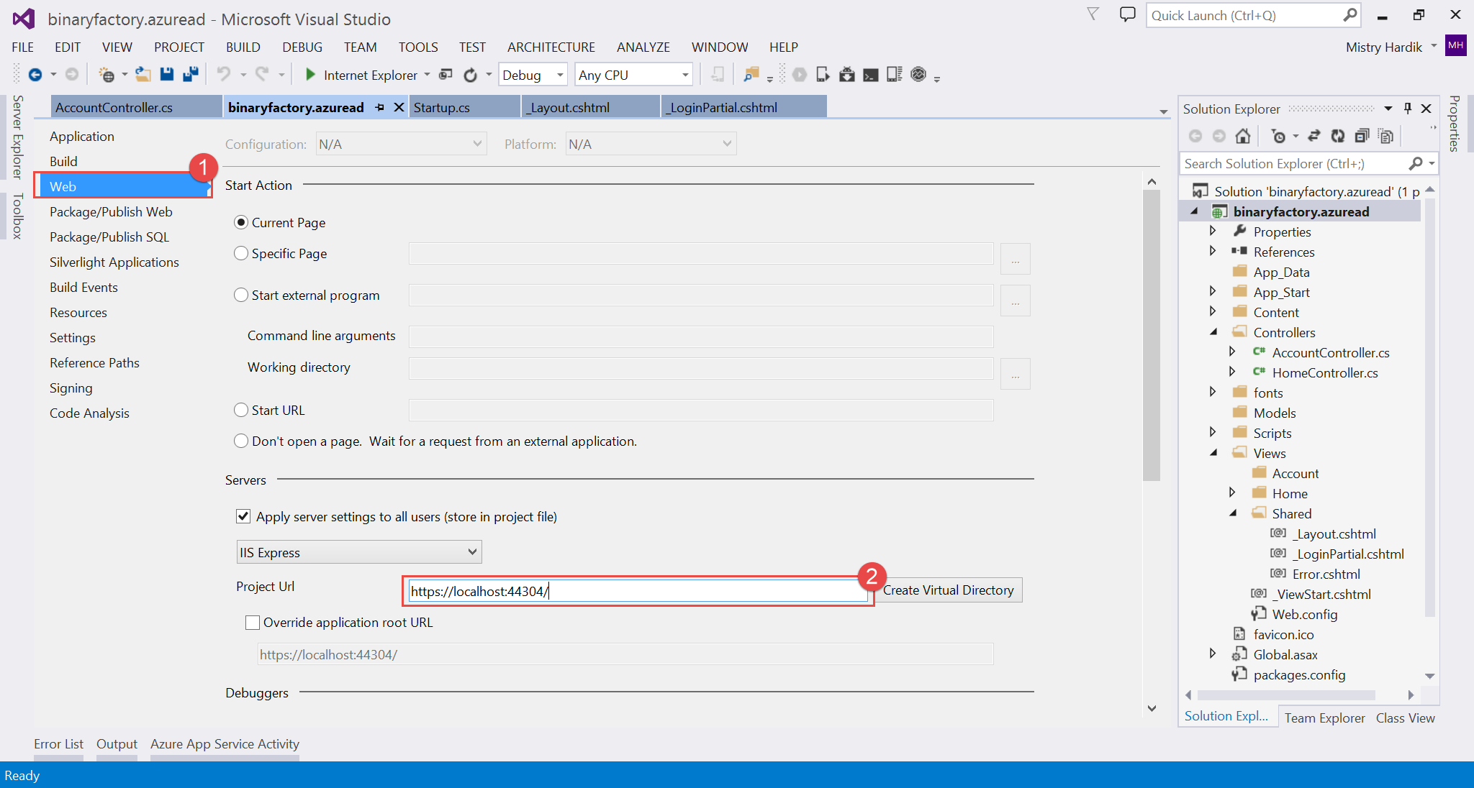

Navigate to your active directory and now register your application to support single sign on

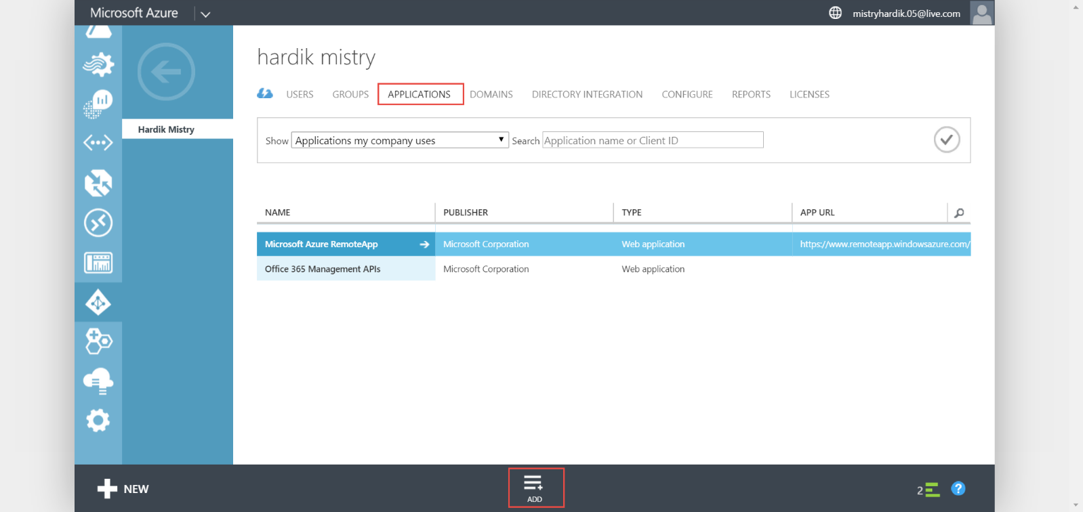

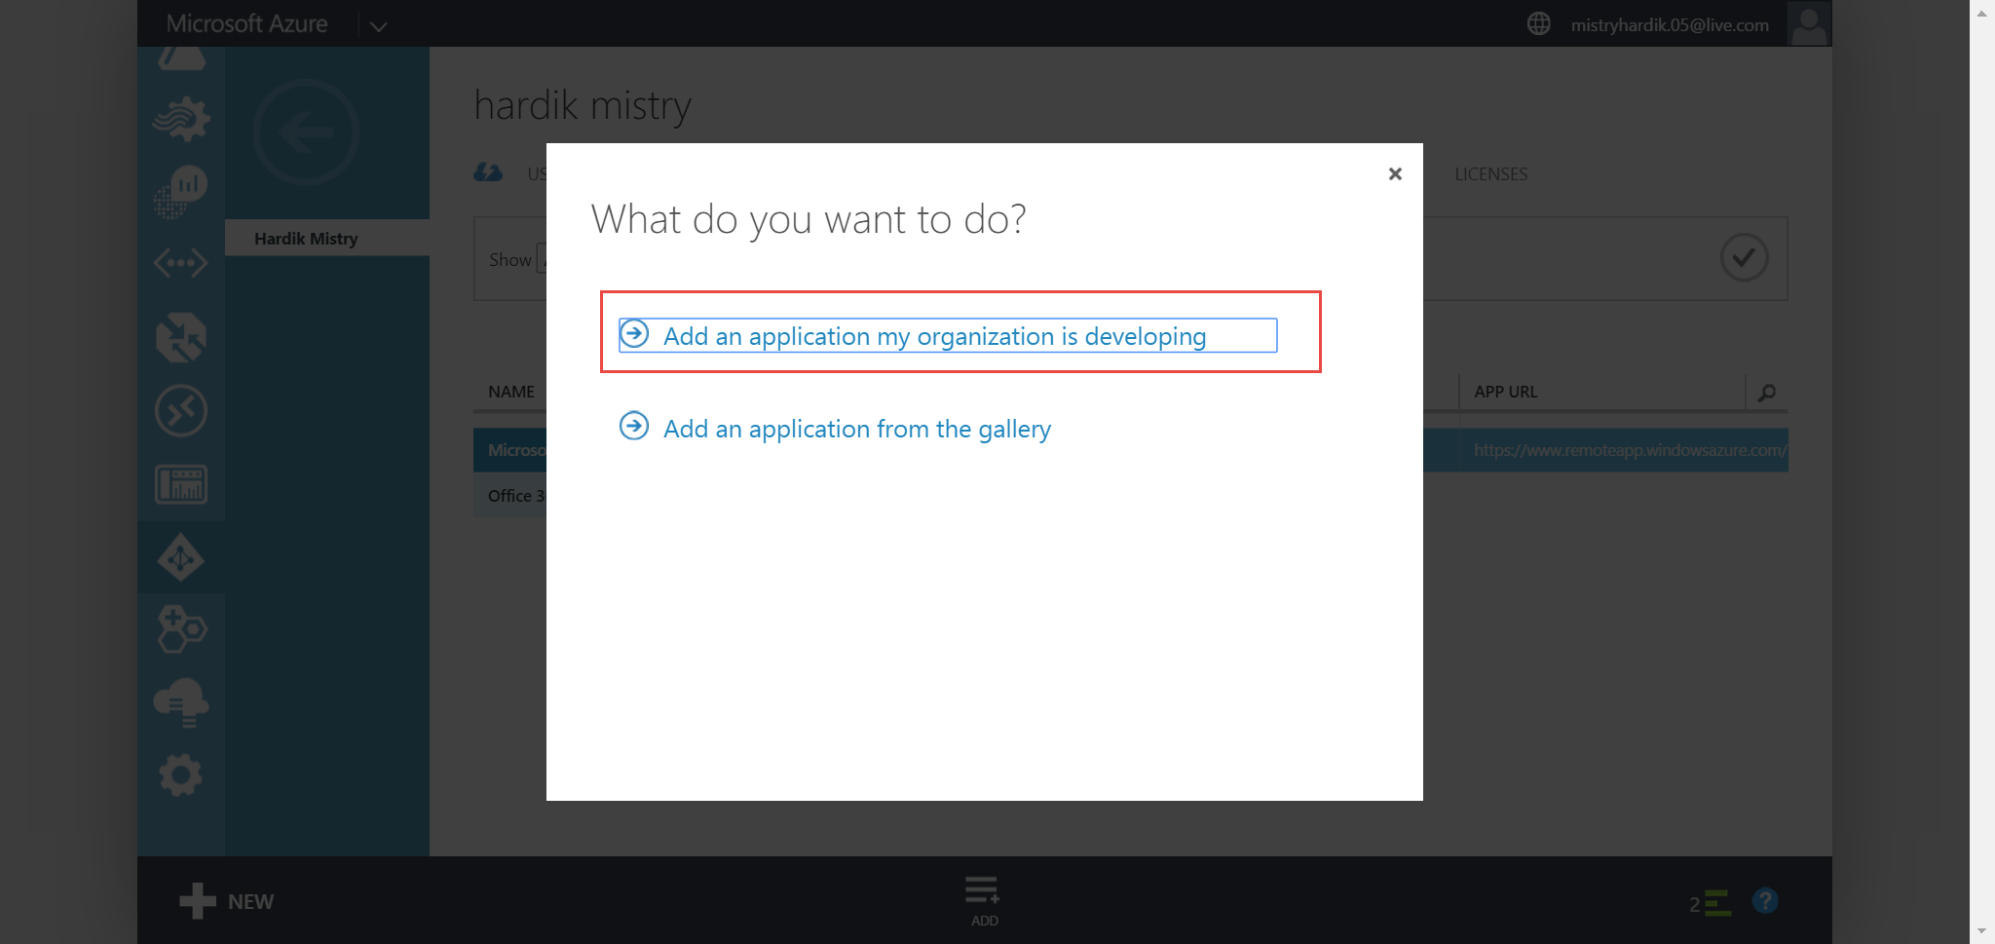

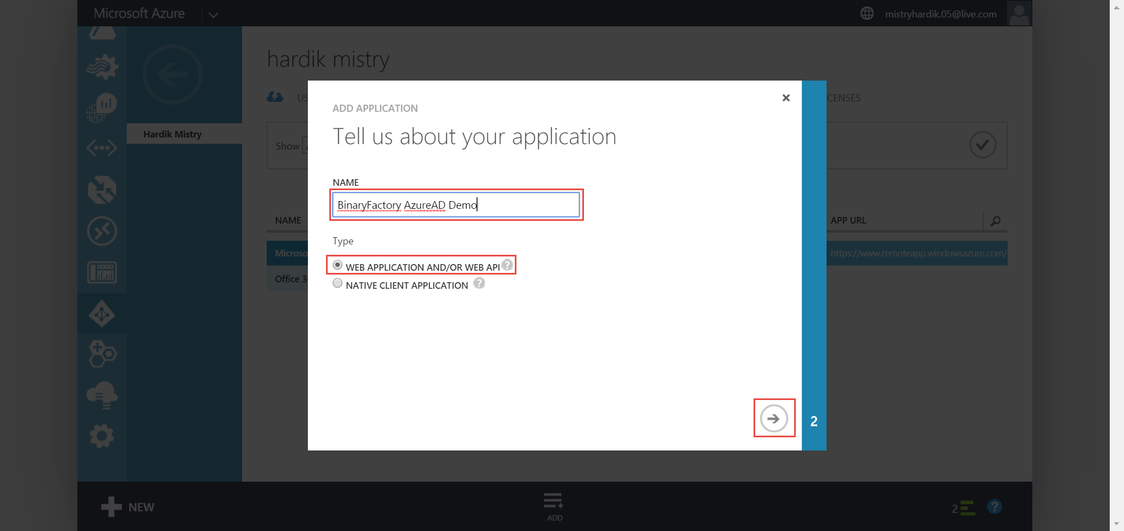

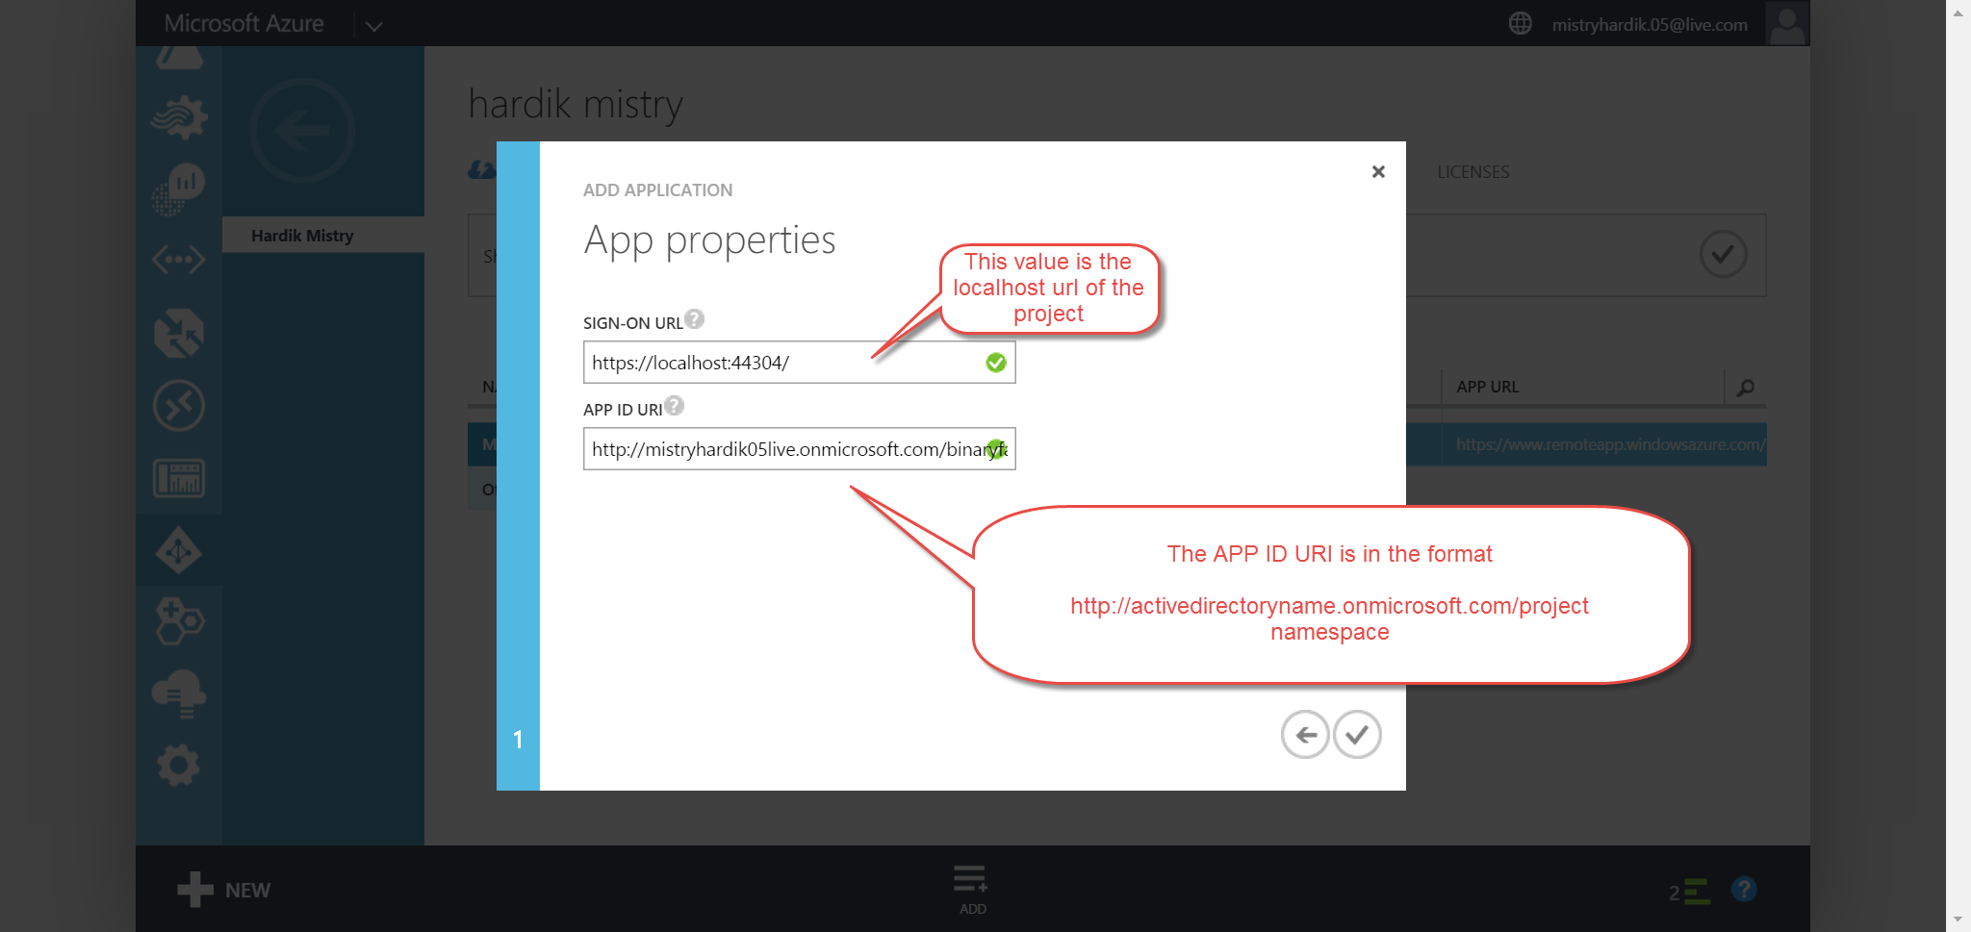

http://suketunayakdatavisionsoluti.onmicrosoft.com/binaryfactory.azuread1

Copy the client id

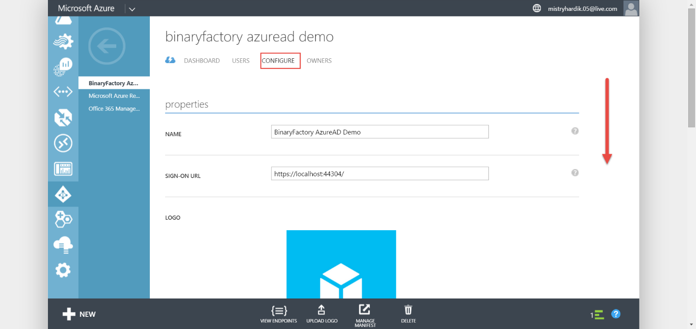

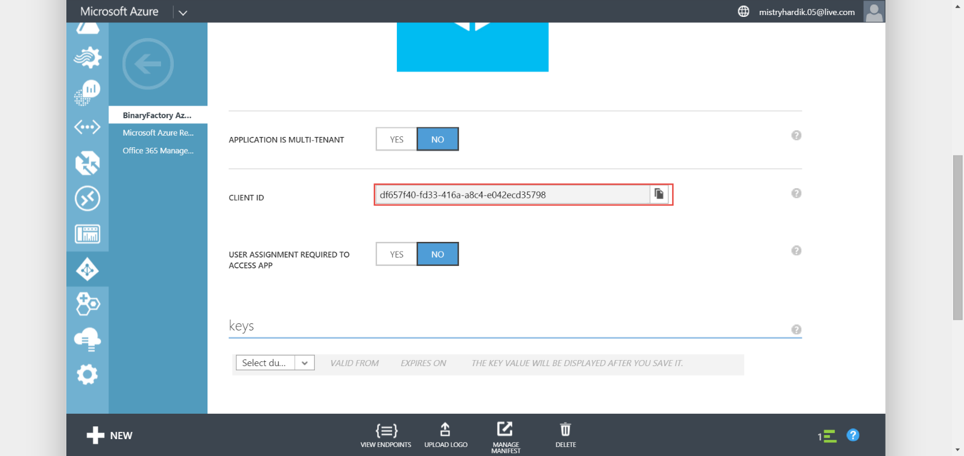

Update the web.config of your root project as shown

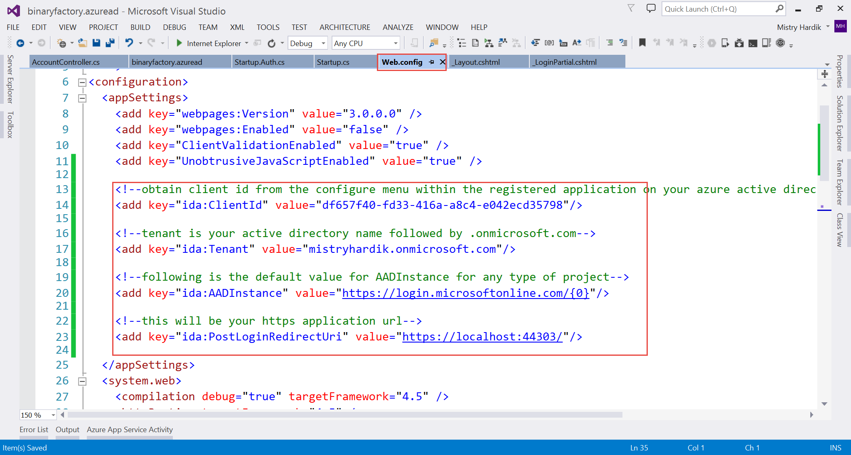

<add key="ida:ClientId" value="ae01a9cb-09ae-459b-8512-ff1d34fc2c0e"/>

<add key="ida:Tenant" value="suketunayakdatavisionsoluti.onmicrosoft.com" />

<add key="ida:AADInstance" value="https://login.microsoftonline.com/{0}"/>

<add key="ida:PostLoginRedirectUri" value="https://localhost:44300/"/>

Run the app

